**Report**

**on**

**FRONT-END ENGINEERING**

**CS186**

by

**Aarush Khanna**

**2110990014**

**G5**

**3rd YEAR**

**INSTRUCTOR’S NAME – MR. LAVISH ARORA**

**Batch 2021**

**Session 2023-24**



The project is based on an E-COMMERCE website for selling Sneakers online and deliver them to any part of the country. The title for the website is ”SNEAKBOX”. It took around 30 days for me to complete the project. The wesbsite has around 30 pages, 14-15 out of which are entirely different and the rest are product based pages. The website is made with the idea that the youth of our country are fond of Sneakers but these type of shoes aren’t easily available in Tier-2 and Tier-3 cities or rural areas . Even the Tier-1 cities face shortage of stock many times and also don’t have much variety. So this website could be great experience for the buyers in buying products easily and at best prices. The most challenging parts of the website have been the header and the home page for me as I wanted to have the best design and structure possible, so I browsed the internet to search for different ideas and came up with a black and white theme which I think is simple but elegant.

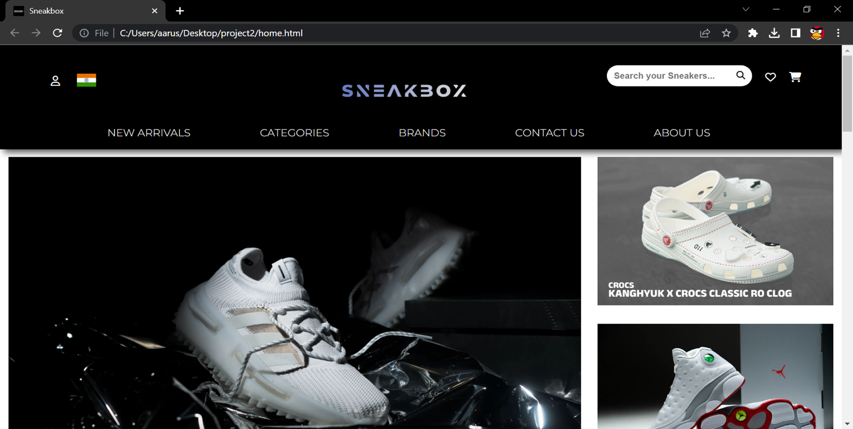

The page shown above is the **HOME PAGE** of the website, you can see the Logo of the website which says “SNEAKBOX” i.e also the title of the website. The website has been given a white and black theme.

On the top the user can see the **NAVIGATION PANEL** i.e the header, which is helpful in browsing throughout different pages in the website.

There are different options available on the navigation panel like “LOGIN”, “NEW ARRIVALS”, “CATEGORIES”, “BRANDS”, “CONTANCT US”, “ABOUT US”, “THE SEARCH BAR”, “CART”, etc.

The **CATEGORIES** option is drop down menu which can navigate the user to pages such as the men’s section, the women’s section and the kid’s section. Also there is a search bar, so that the user can easily search the desired product by just typing the name.

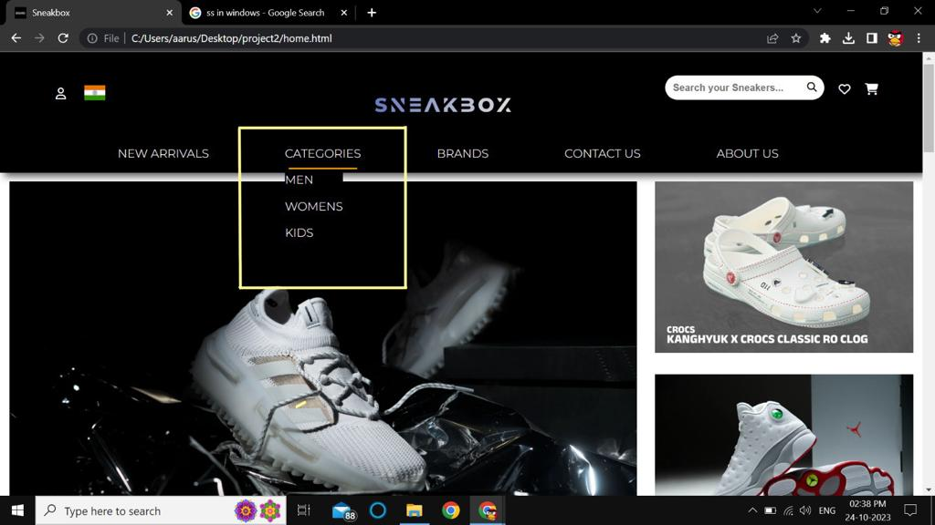

After the navigation panel, Come the posters for our hero products. These products are the latest and are selected on the basis of sales and style by our experts.

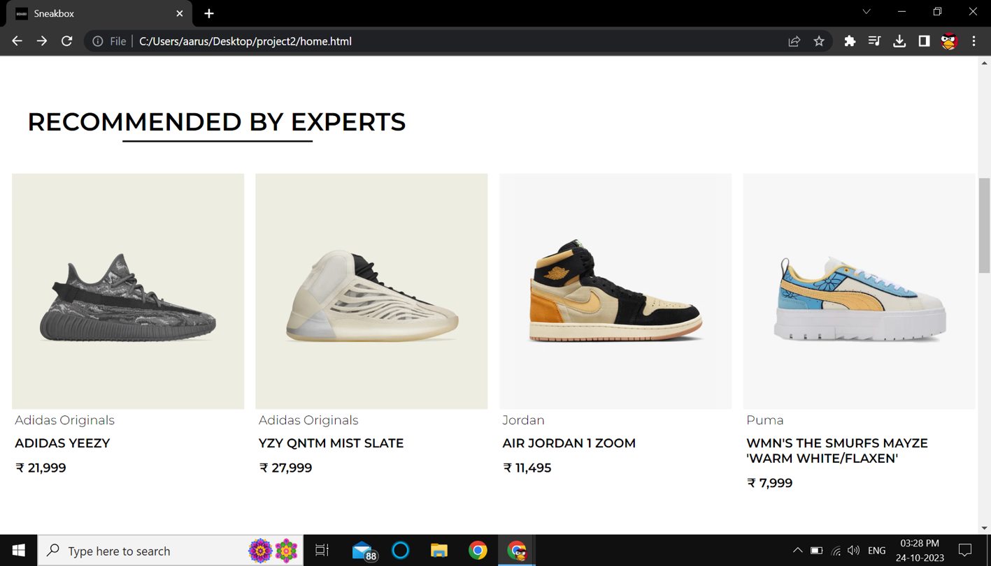

Then comes the **RECOMMENDED BY EXPERTS** section of the Home page. Where products are hand picked by the experts on the basis of comfortability and durability.

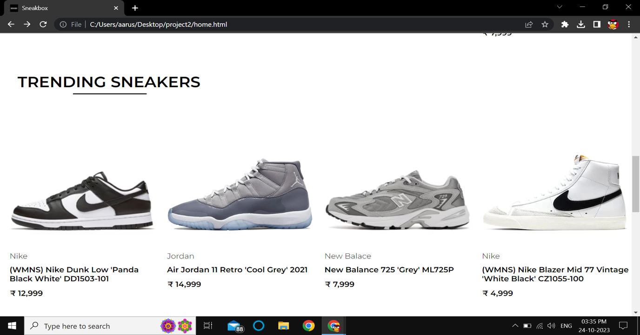

After this, there is a **TRENDING SNEAKERS** section.

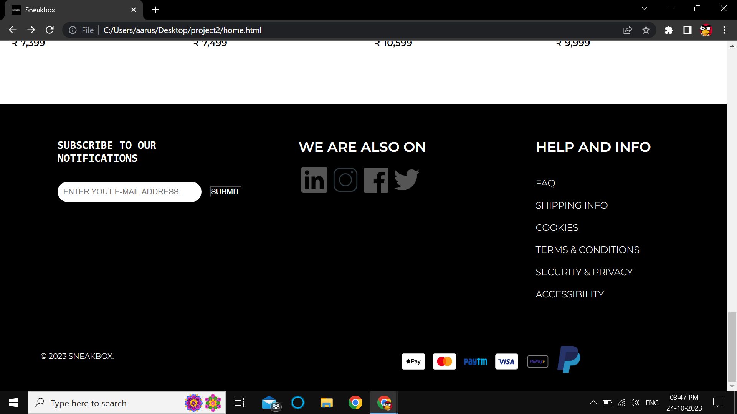

In the last we have the **FOOTER** of the website which consist of copyright notice, social media icons, option for subscribing to our newsletter through e-mail, link to terms and conditions, icons of payment options, etc.

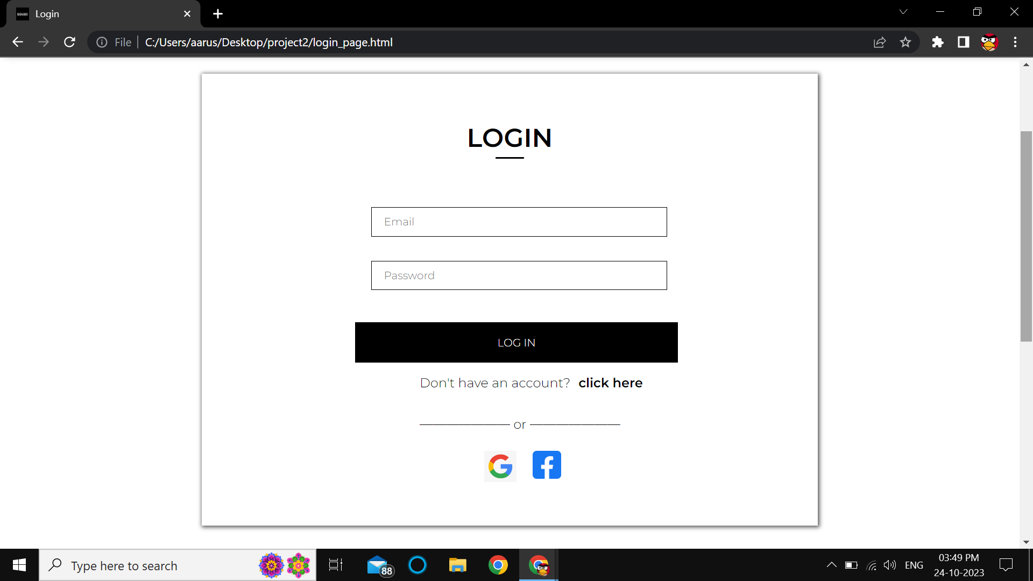

This is the **LOGIN PAGE** of the website where users can Login to their “SNEAKBOX” account by using their e-mail id and password. The users can also Login using Google and Facebook accounts. Also if a user doesn’t have an account in “SNEAKBOX”, then the user can sign up by clicking on “CLICK HERE” below the Login Button which will land the user to the **SIGN UP PAGE**.

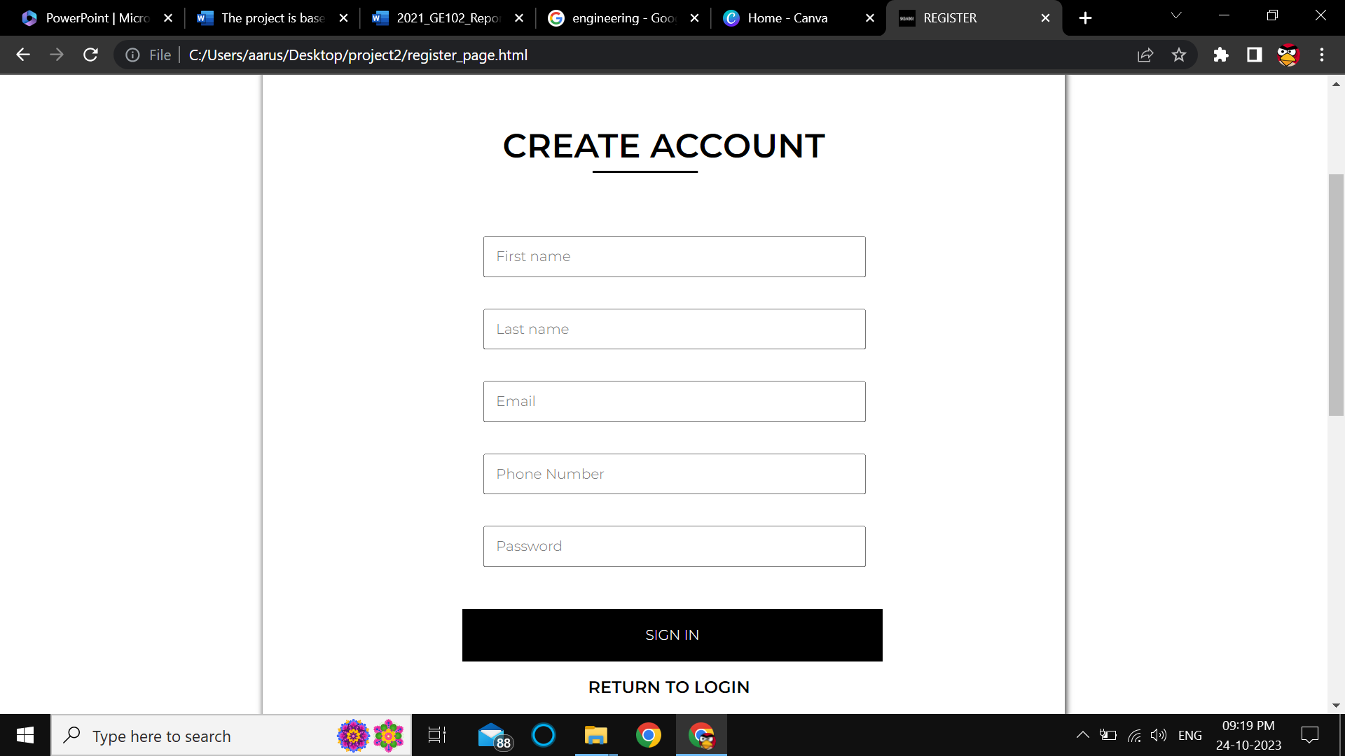

This is the **SIGN UP PAGE** of the website where users can register themselves on “SNEAKBOX” by providing us with their personal details such as first name, last name, e-mail id, phone number and the password they would like to choose for their account. The users can also register via their Google and Facebook accounts.

Also the user can return to the **LOGIN PAGE** by clicking on “RETURN TO LOGIN” option below the Sign in button.

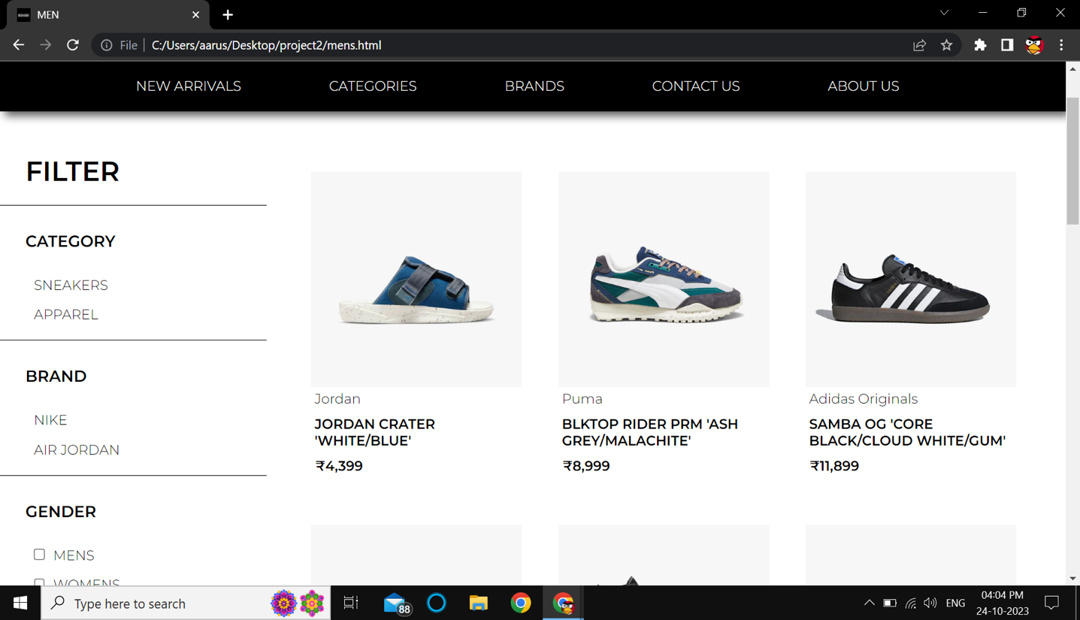

This is Men’s category page where the products have been sorted for male customers. Also every category page has been provided with a filter section on the left where the customer can choose personalized products such Sneakers or Apparels, the user can choose a specific brand or even the gender. The user can even get the list of the products available in a specific size. All the sizes are given in the filter section. Further the use can sort products of a particular price range. For e.g. by clicking on the price range ₹10,000 - ₹14,999, the user gets list of products between this price range.

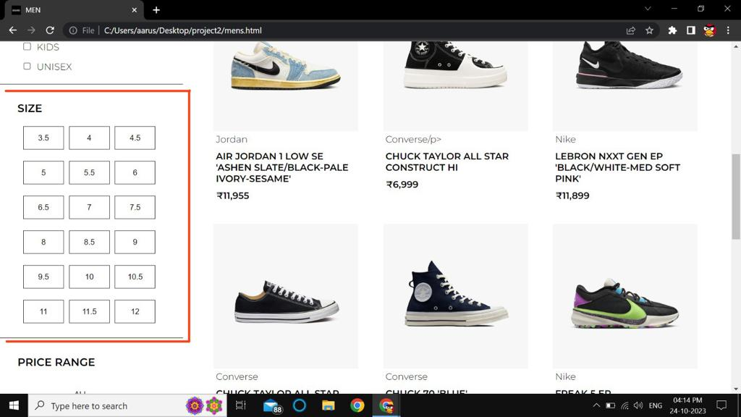

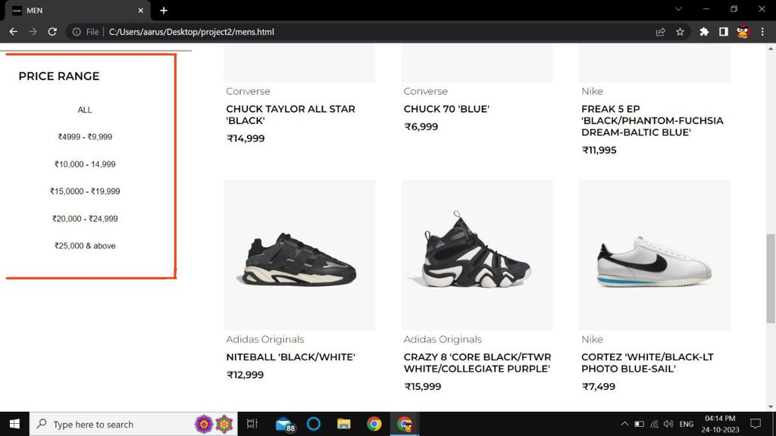

Below are the Screenshots for women’s category page

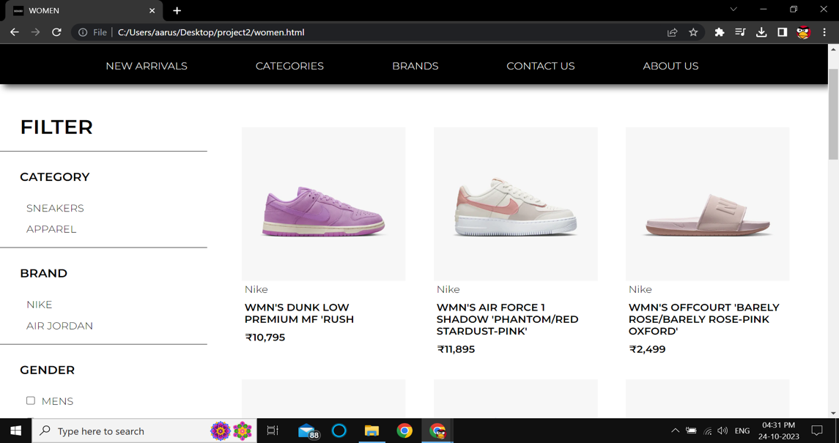

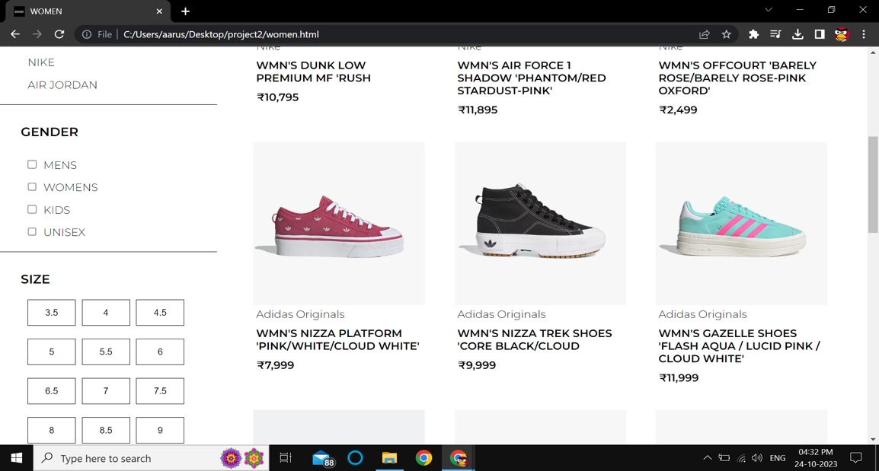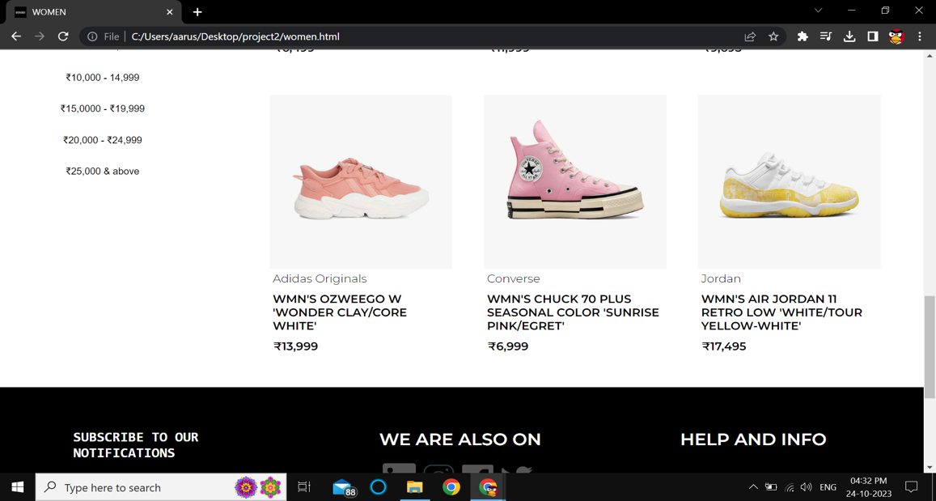

Below are Screenshots for Kid’s category page

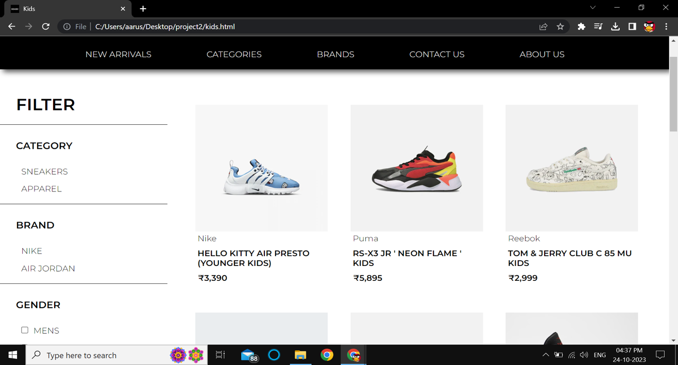

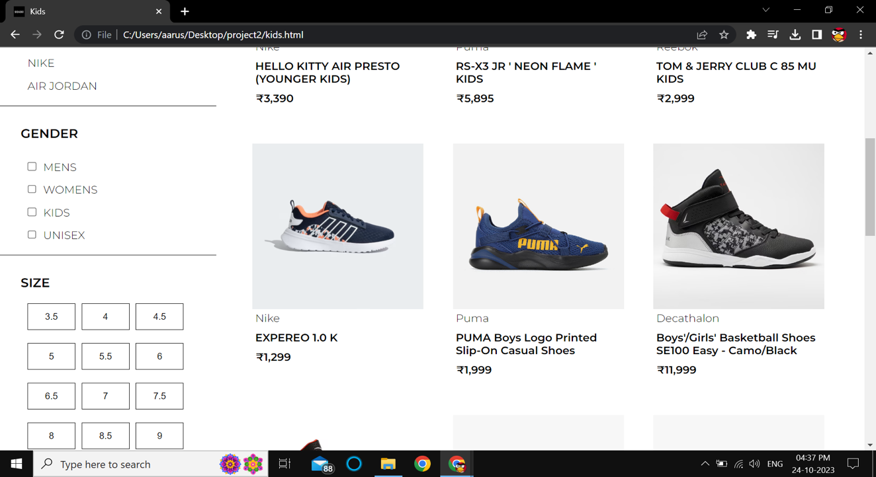

Below is **NEW ARRIVALS** **PAGE** where the latest products on our website have been listed.

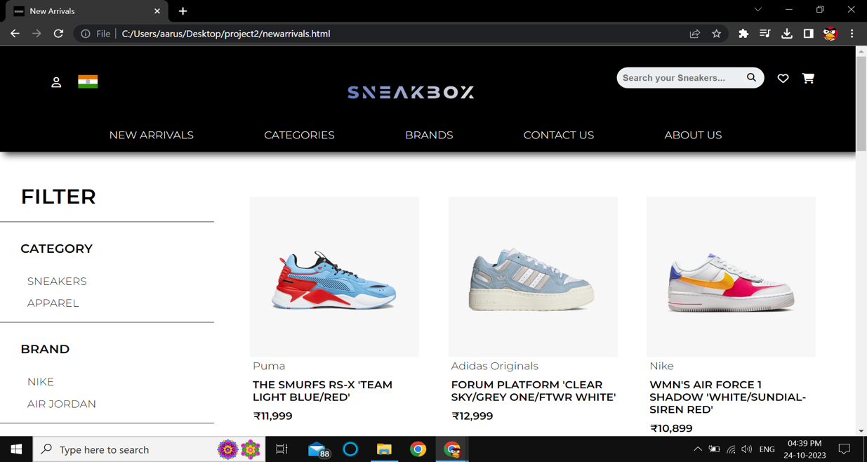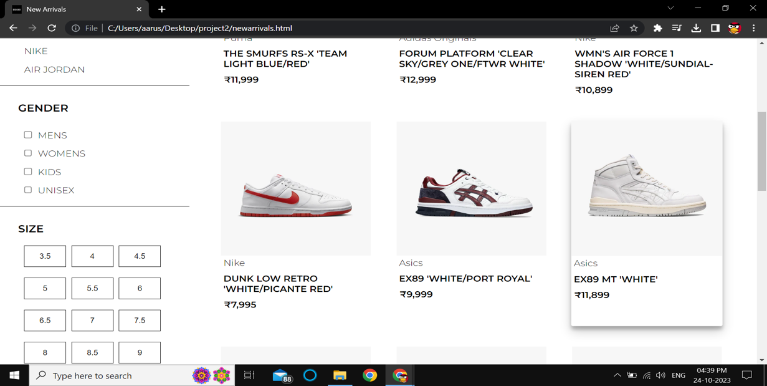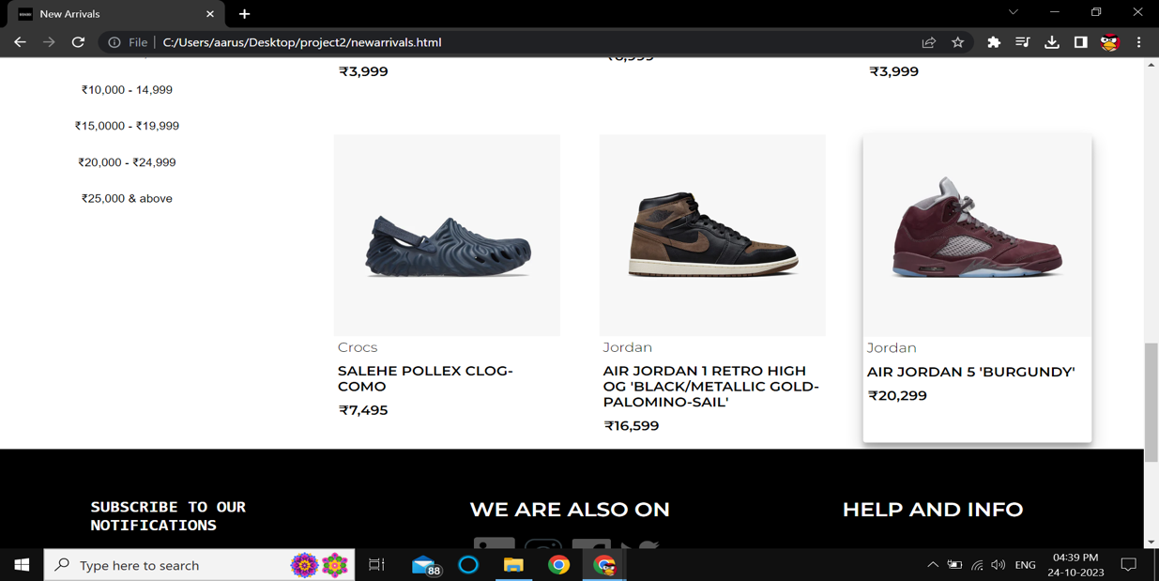

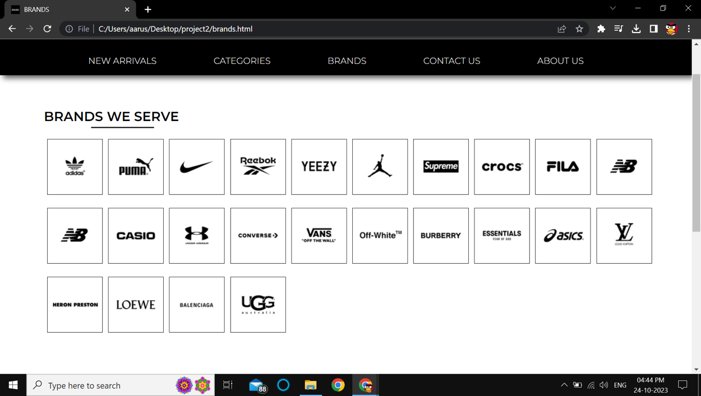

The navigation panel also has an option named as “BRANDS” which on clicking lands the user to a page where all the brands our website serves have been listed.

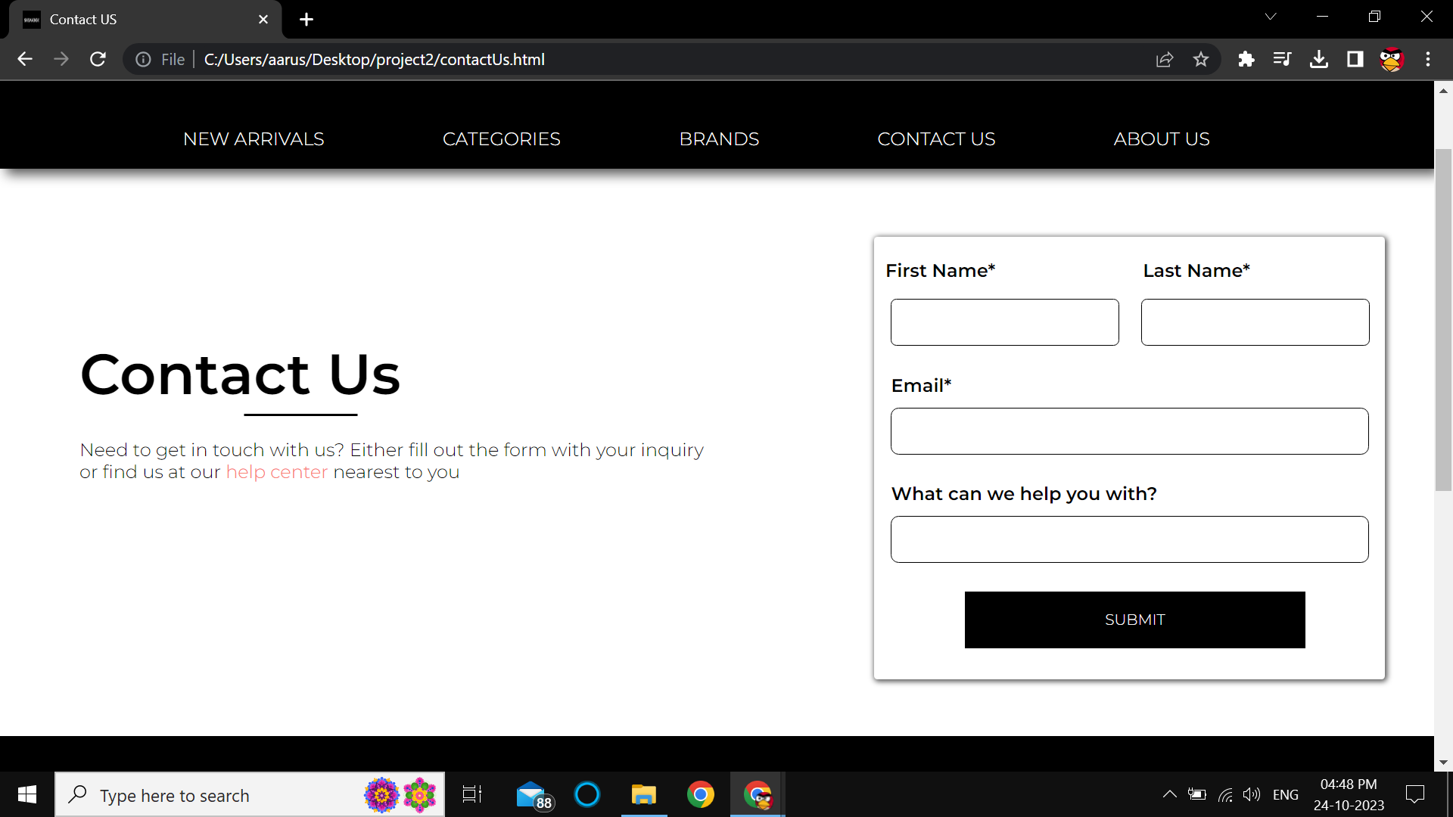

This is the Contact Us page which consist of a form, which can be filled by the user if he/she has any complaints regarding the website or any product. If the user wishes to visit our help center then he/she can click on the help center button and get the address of the nearest help center.

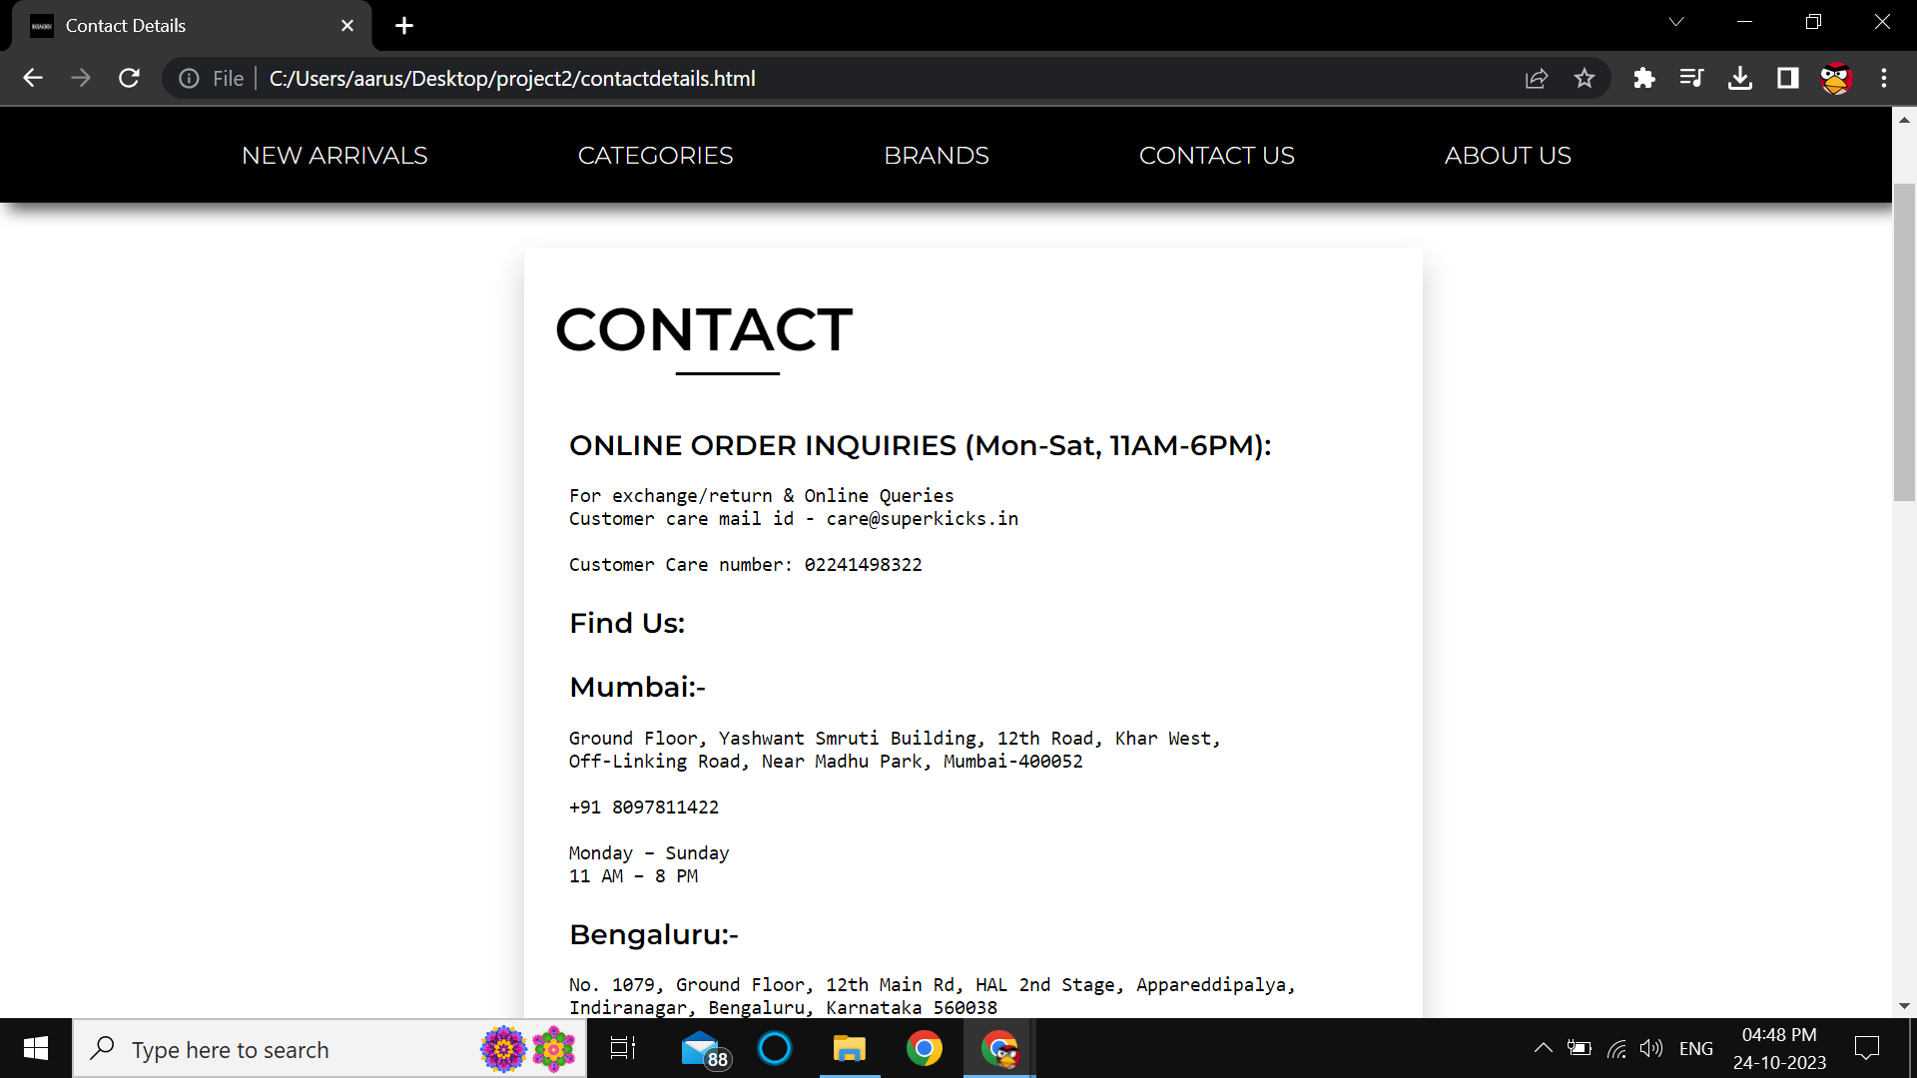

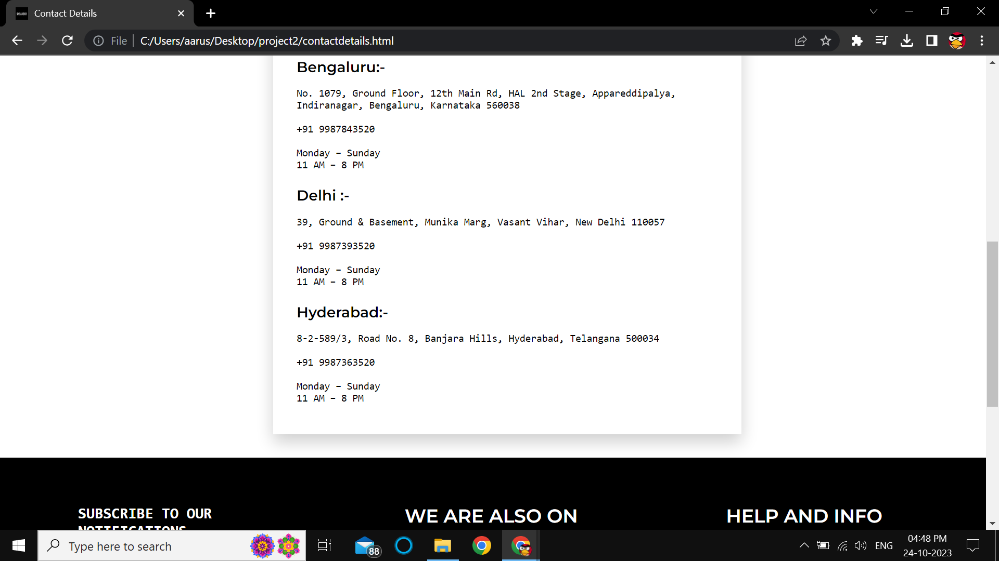

Below are Screenshots for the **ABOUT US PAGE**

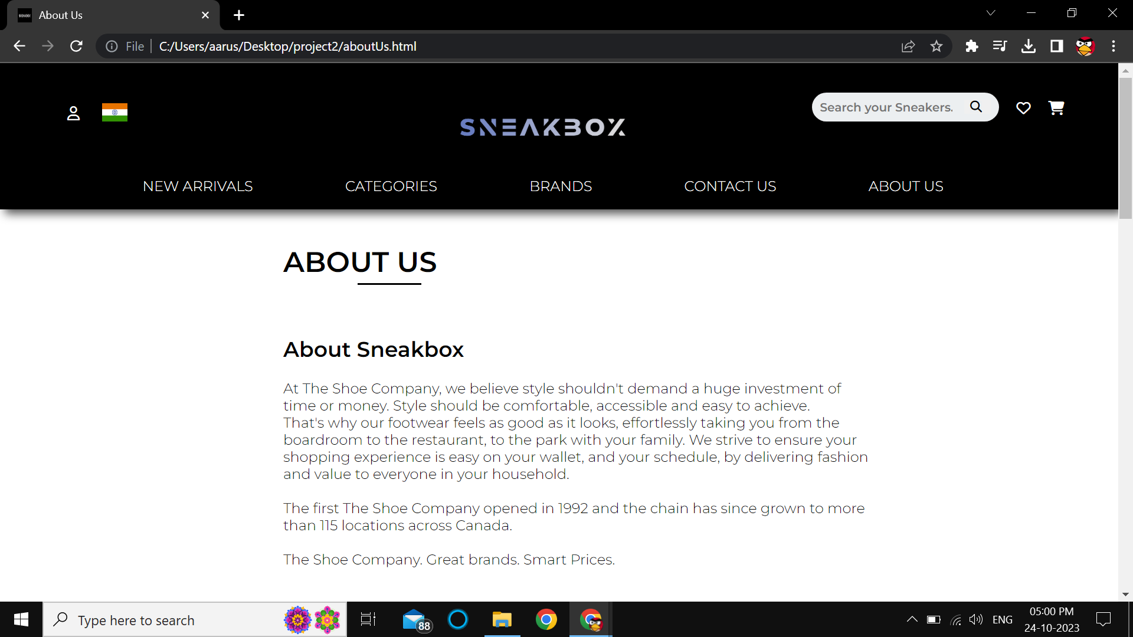

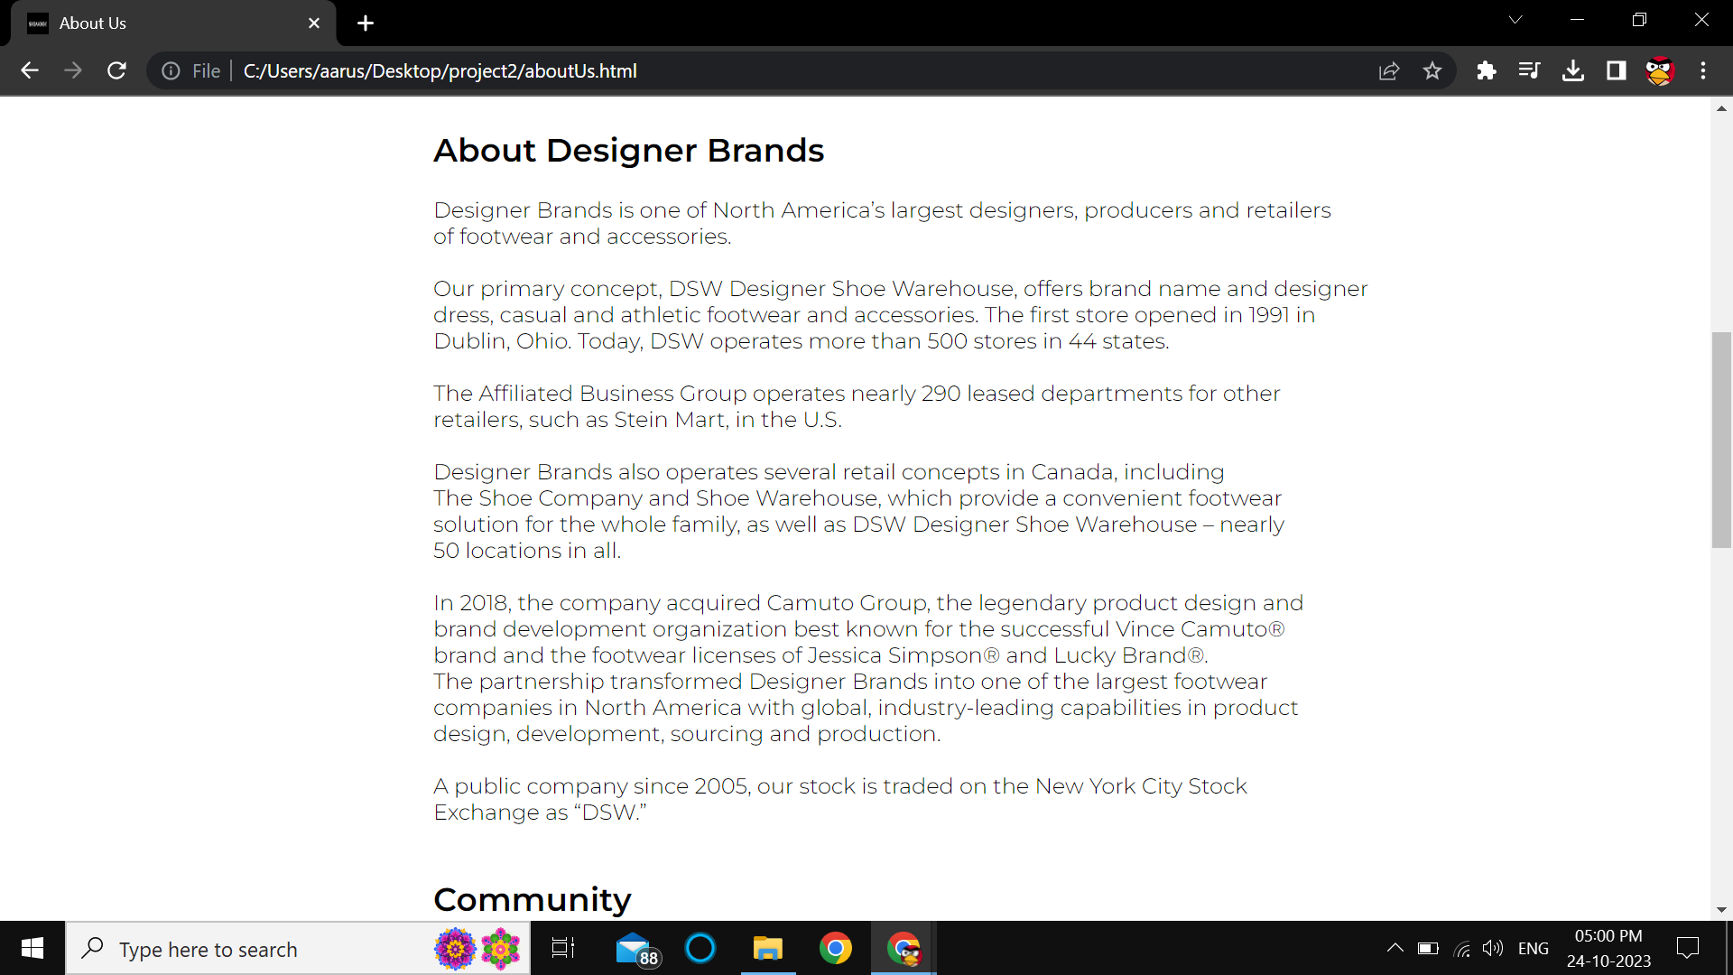

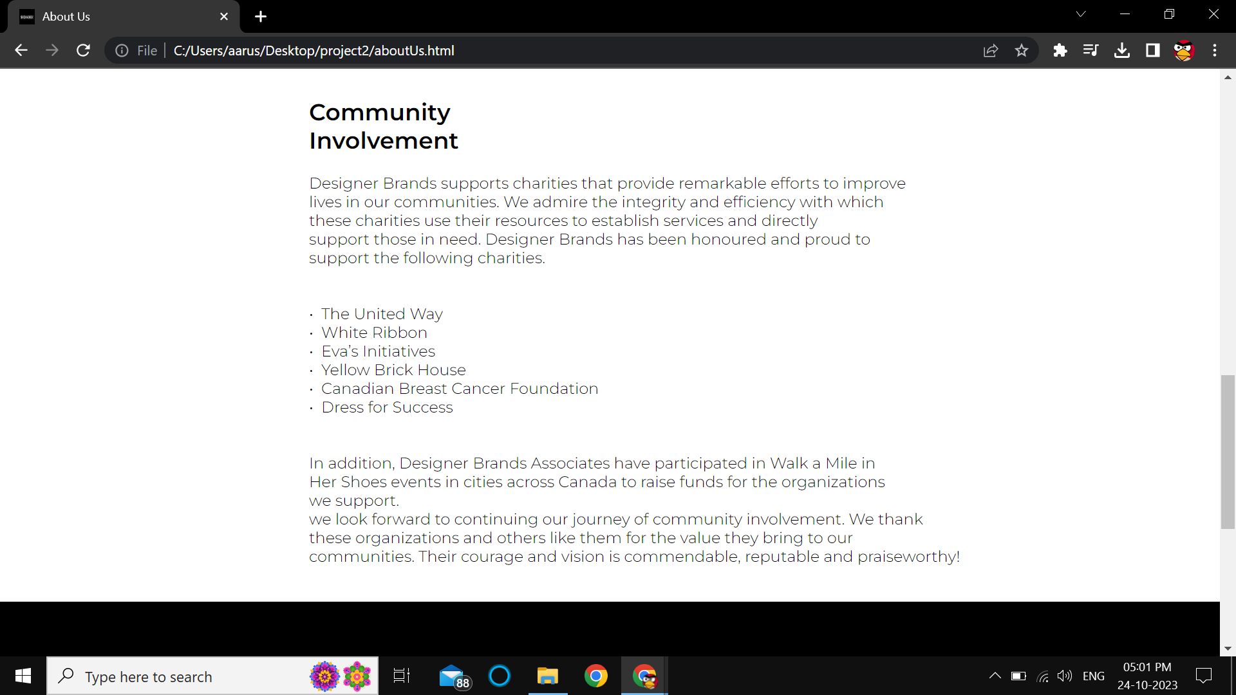

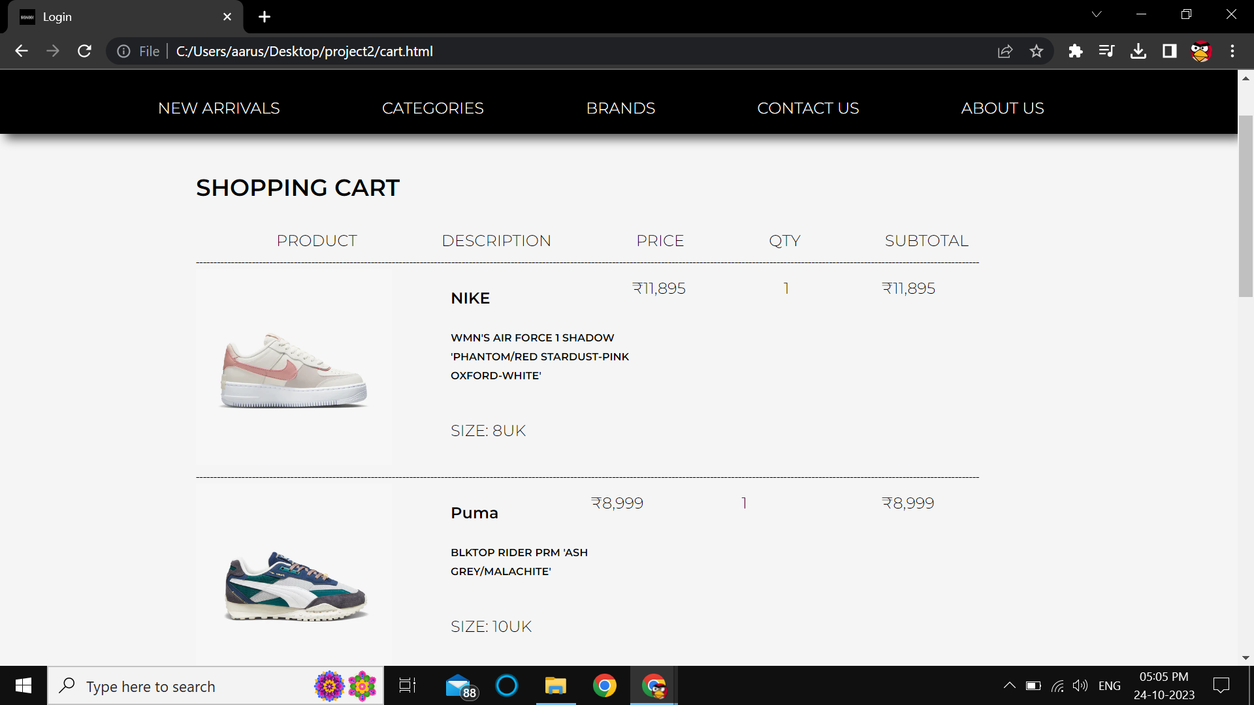

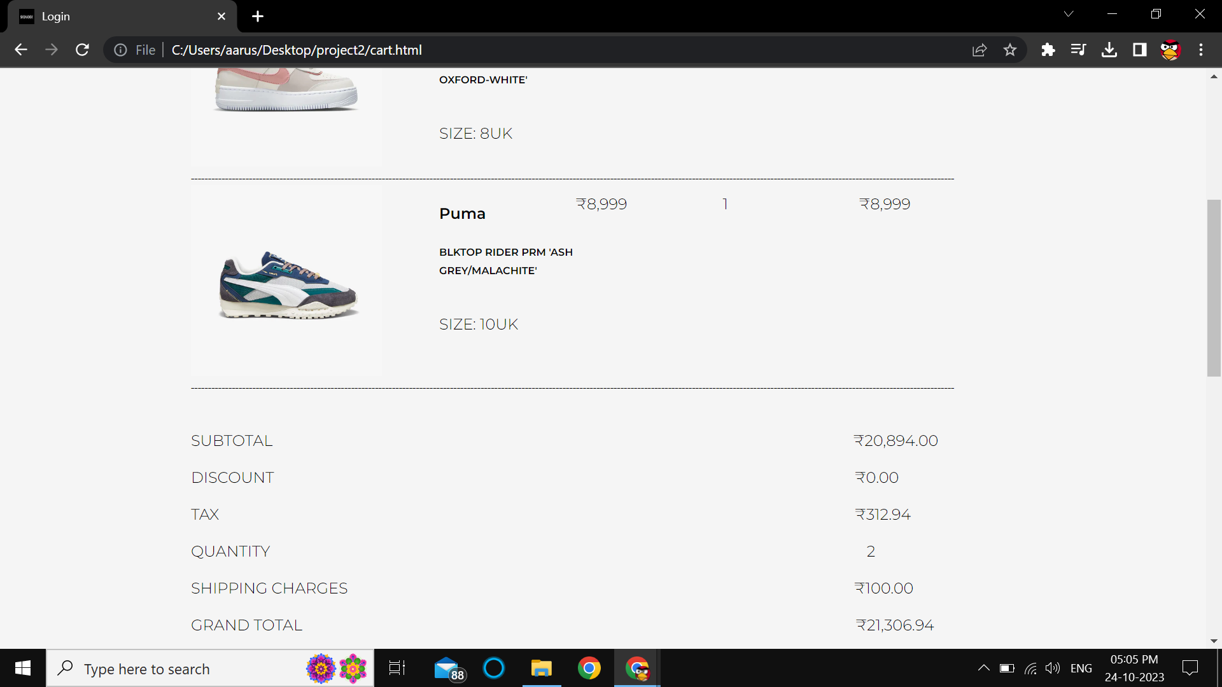

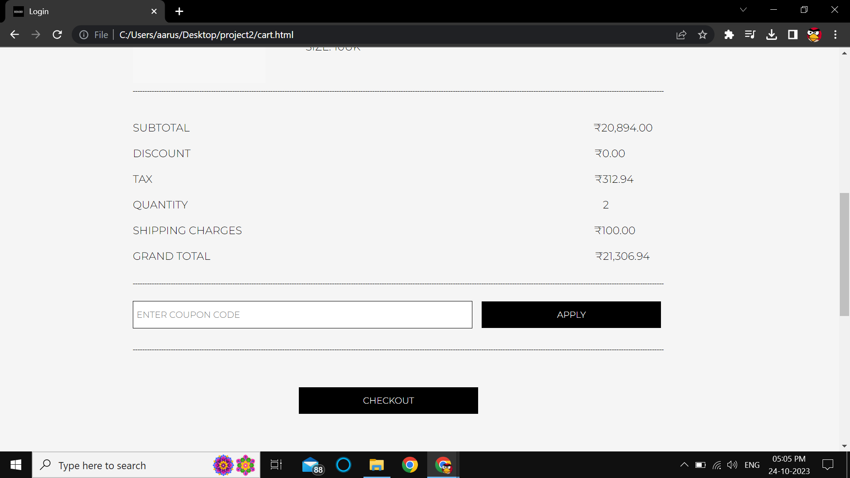

This is **CART** of the website, whenever a person wishes to buy a product, it is added to the cart, the total quantity and the total price of the products are mentioned in the bottom and there is an option to enter the coupon code no., if the user has any....

Further the can checkout and pay for products in the payment section.

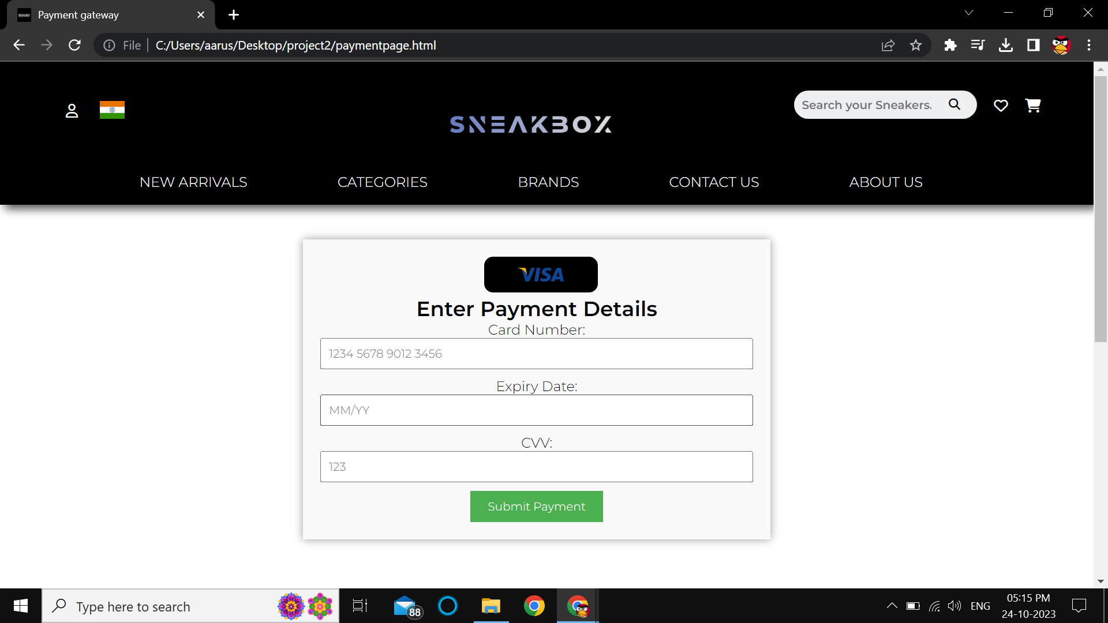

After clicking the checkout/buy now button the user lands on the shipping details page. The can here enter his/her address and contact number where they want the product to be delivered and then continue to payment gateway.



This is **PAYMENT GATEWAY PAGE**

The Card details are entered by the user and the payment will be successful. If this page is submitted without entering anything then it would show invalid input and the user has to enter the details in order to complete the order.

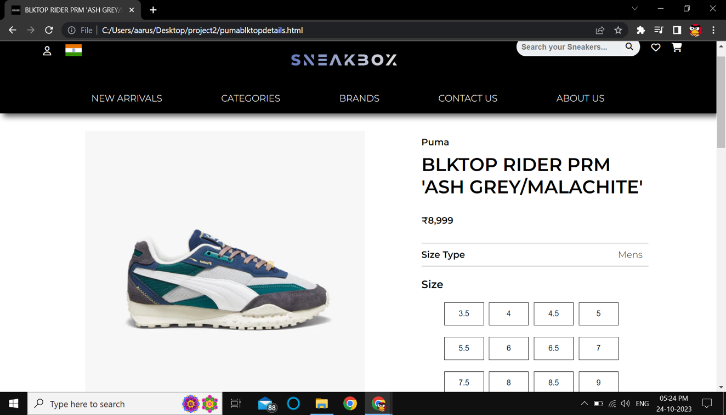

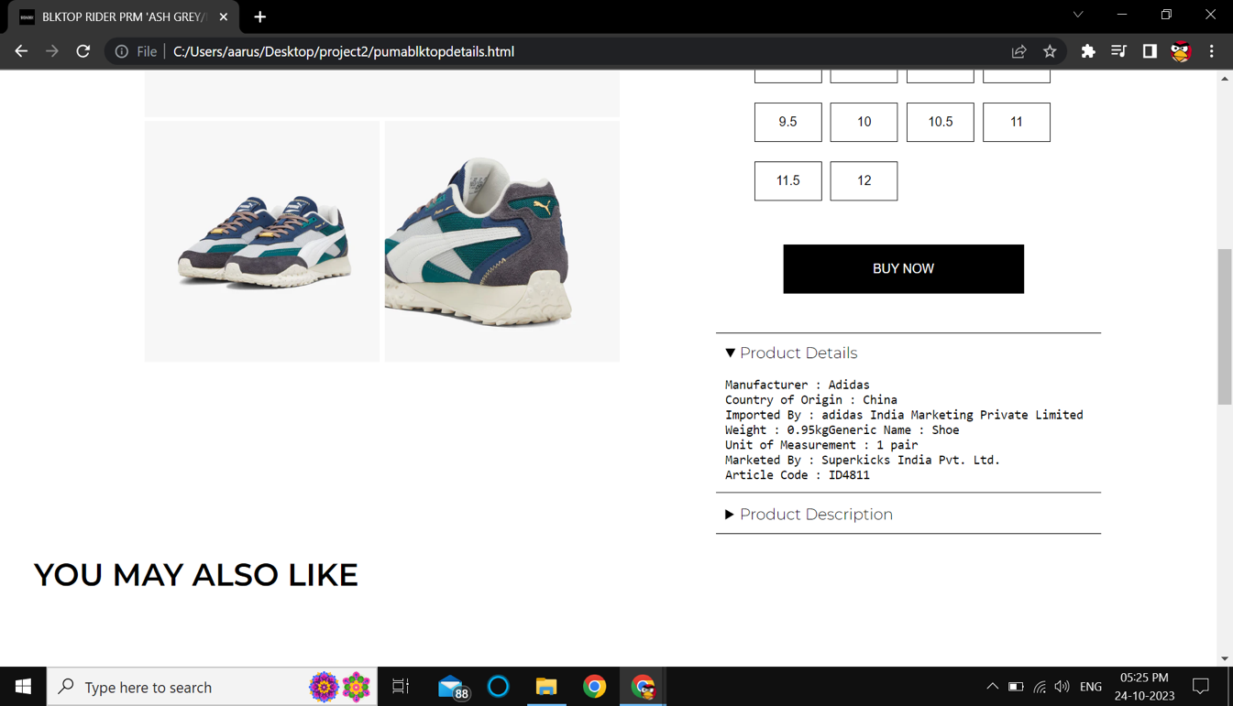

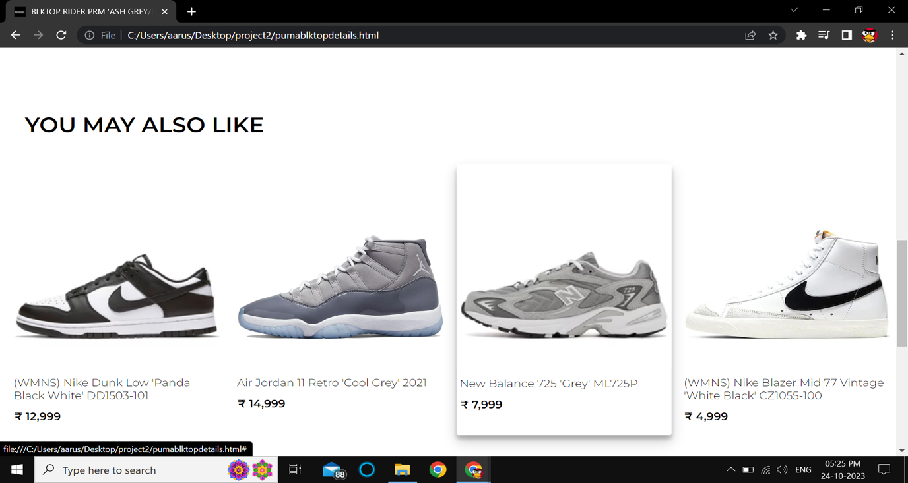

This is **PRODUCT DETAILS PAGE** of the website where every detail of a product is mentioned like the price, product type(men or women), brand, product name, available sizes, manufacturer details, origin, article code are given.

After then there is a section where **PRODUCTS YOU MAY ALSO LIKE** are listed.